**ANSWERS TO ASSIGNMENT ON ENVIRONMENT SETUP**

1. **Select Your Operating System (OS):**

**Choose an operating system that best suits your preferences and project requirements. Download and Install Windows 11.**

**shifted from windows my OS is Parrot OS ;**

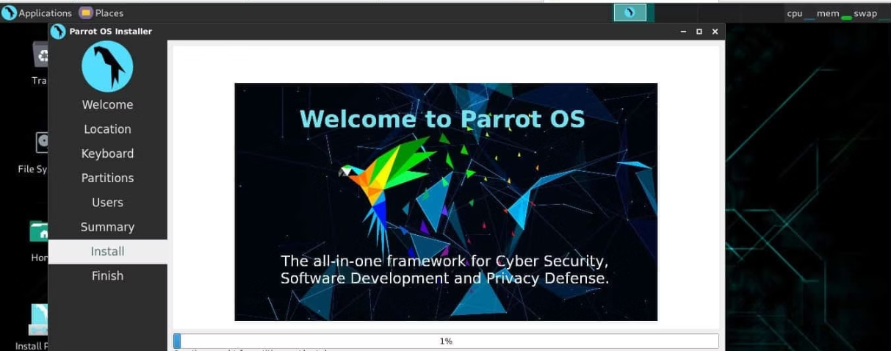

1. **Install a Text Editor or Integrated Development Environment (IDE):**

**Select and install a text editor or IDE suitable for your programming languages and workflow. Download and Install Visual Studio Code.** [**https://code.visualstudio.com/Downlo**](https://code.visualstudio.com/Downlo)

**Already installed visual studio ;**

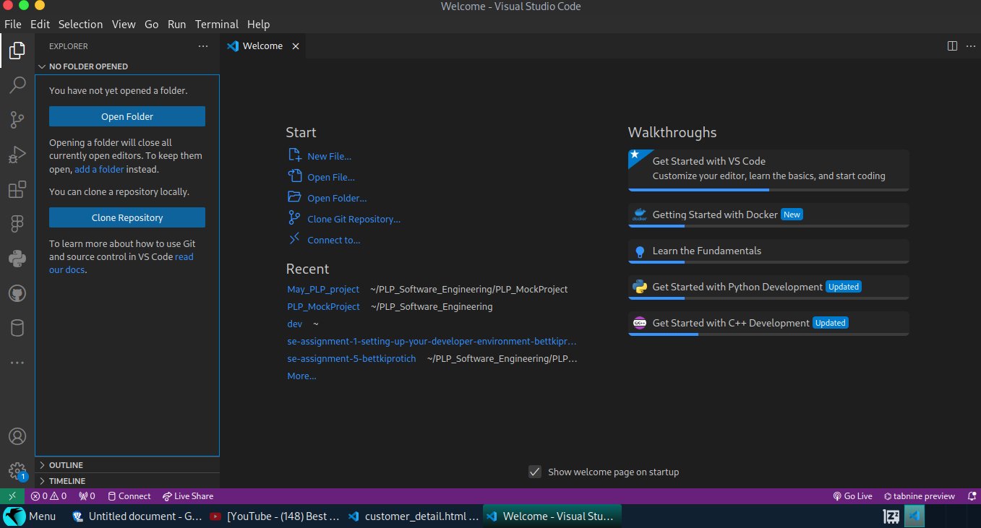

1. **Set Up Version Control System:**

**Install Git and configure it on your local machine. Create a GitHub account for hosting your repositories. Initialize a Git repository for your project and make your first commit.** [**https://github.com**](https://github.com)

**Already done all that before the question in previous projects;**

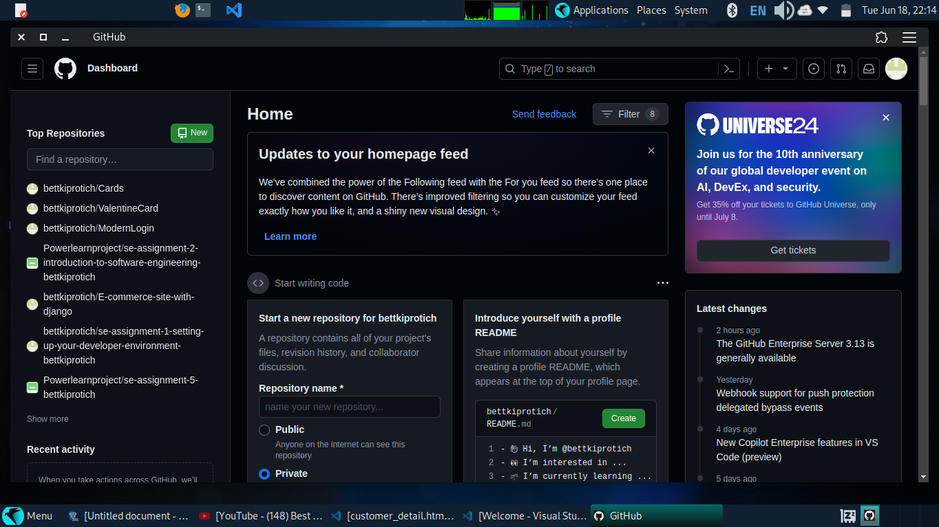

1. **Install Necessary Programming Languages and Runtimes:**

**Instal Python from http://wwww.python.org programming language required for your project and install their respective compilers, interpreters, or runtimes. Ensure you have the necessary tools to build and execute your code.**

**I had python already installed and all the necessary tools;**

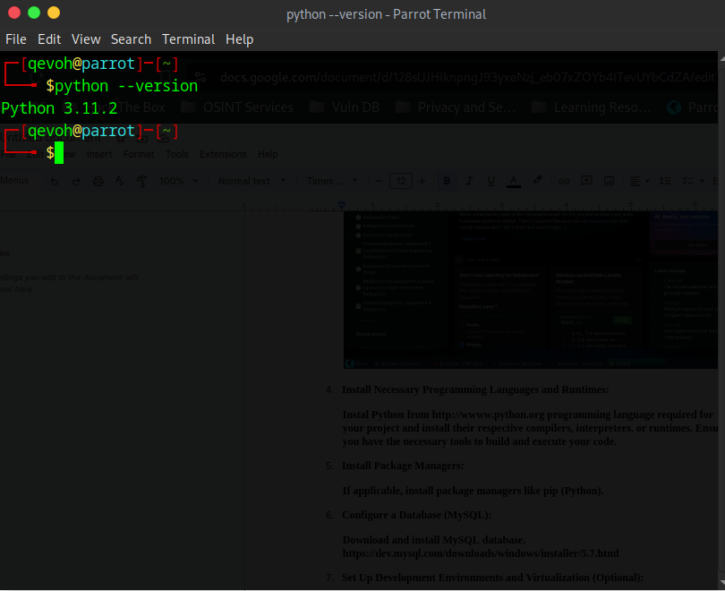

1. **Install Package Managers:**

**If applicable, install package managers like pip (Python).**

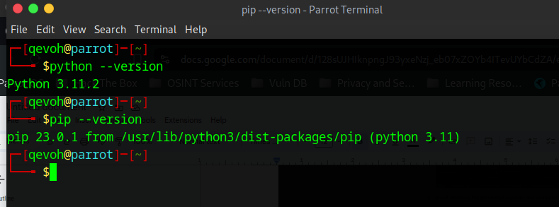

1. **Configure a Database (MySQL):**

**Download and install MySQL database.** [**https://dev.mysql.com/downloads/windows/installer/5.7.html**](https://dev.mysql.com/downloads/windows/installer/5.7.html)

**Already installed mysql ;**

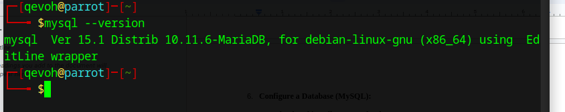

1. **Set Up Development Environments and Virtualization (Optional):**

**Consider using virtualization tools like Docker or virtual machines to isolate project dependencies and ensure consistent environments across different machines.**

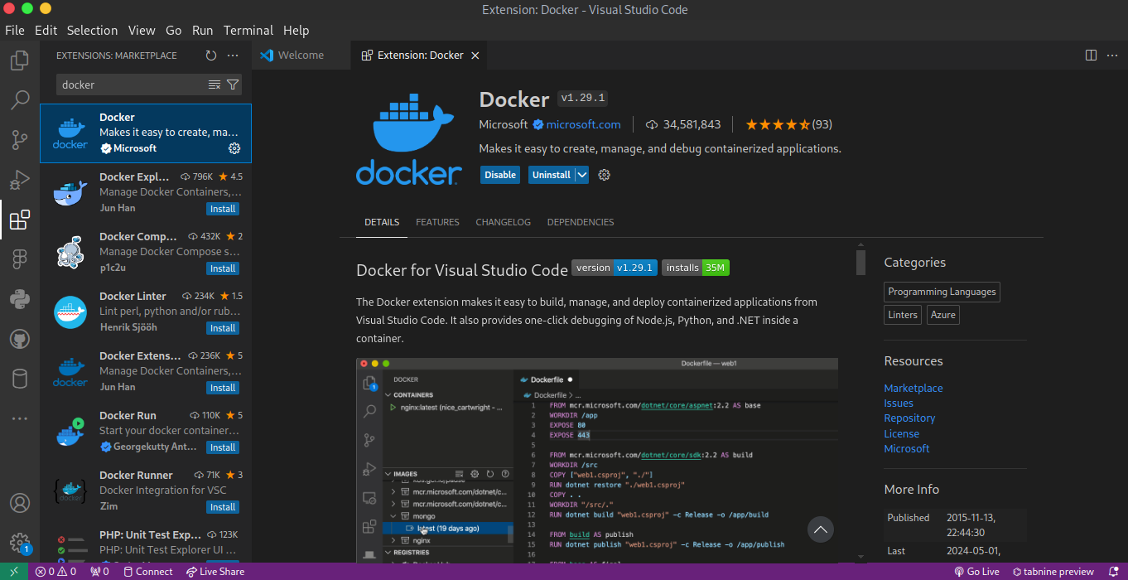

1. **Explore Extensions and Plugins:**

**Explore available extensions, plugins, and add-ons for your chosen text editor or IDE to enhance functionality, such as syntax highlighting, linting, code formatting, and version control integration.**

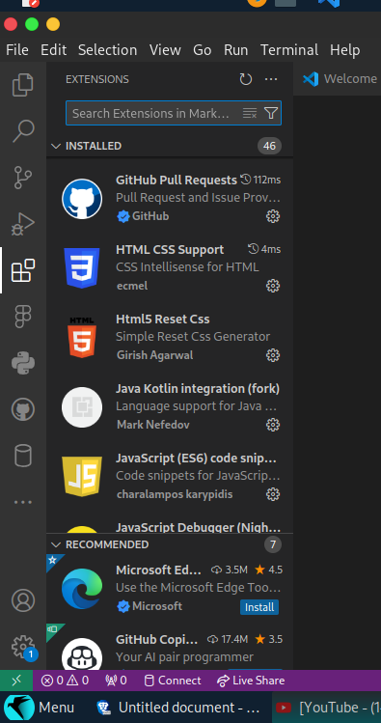

1. **Document Your Setup:**

**Create a comprehensive document outlining the steps you've taken to set up your developer environment. Include any configurations, customizations, or troubleshooting steps encountered during the process.**

**Developer Environment Setup Documentation: VS Code on Parrot OS**

This document outlines the steps taken to set up a developer environment using Visual Studio Code (VS Code) on Parrot OS. It includes software installation, configurations, customizations, and troubleshooting steps encountered during the process.

**Software Installation**

**Update Parrot OS**

- Before installing new software, update the system to ensure all packages are up-to-date:

```sh

sudo apt update

sudo apt upgrade

```

**Install Visual Studio Code**

**Download and Install VS Code**

- Open a terminal and run the following commands to add the Microsoft GPG key and repository:

```sh

wget -qO- https://packages.microsoft.com/keys/microsoft.asc | gpg --dearmor > packages.microsoft.gpg

sudo install -o root -g root -m 644 packages.microsoft.gpg /usr/share/keyrings/

sudo sh -c 'echo "deb [arch=amd64 signed-by=/usr/share/keyrings/packages.microsoft.gpg] https://packages.microsoft.com/repos/vscode stable main" > /etc/apt/sources.list.d/vscode.list'

rm -f packages.microsoft.gpg

```

- Install VS Code:

```sh

sudo apt update

sudo apt install code

```

---

**Configurations**

**Visual Studio Code**

**Launch VS Code**

**-** Open VS Code from the application menu or by typing `code` in the terminal.

**Extensions**

**- Install essential extensions:**

- Open the Extensions view by clicking the Extensions icon in the Activity Bar or pressing `Ctrl+Shift+X`.

**- Search for and install the following extensions:**

- Prettier - Code formatter

- ESLint

- GitLens

- Docker

- Python

**Settings**

**-** Open VS Code settings (`File` > `Preferences` > `Settings` or `Ctrl+,`).

- Configure user settings (`settings.json`):

```json

{

"editor.fontFamily": "Fira Code, Consolas, 'Courier New', monospace",

"editor.fontSize": 14,

"editor.tabSize": 2,

"editor.formatOnSave": true,

"eslint.enable": true,

"prettier.singleQuote": true,

"prettier.trailingComma": "all"

}

**Git Configuration**

- Set up Git with your username and email:

```sh

git config --global user.name "Your Name"

git config --global user.email "your.email@example.com"

```

**Additional Tools**

**Python**

- Install Python and pip:

```sh

sudo apt install python3 python3-pip

```

- Verify installation:

```sh

python3 --version

pip3 --version

```

**Docker**

- Install Docker:

```sh

sudo apt install docker.io

```

- Start Docker and enable it to run at startup:

```sh

sudo systemctl start docker

sudo systemctl enable docker

```

- Verify Docker installation:

```sh

docker --version

```

---

**Customizations**

**Terminal Customization**

#Oh My Zsh

- Install Oh My Zsh:

```sh

sudo apt install zsh

sh -c "$(curl -fsSL https://raw.githubusercontent.com/ohmyzsh/ohmyzsh/master/tools/install.sh)"

```

- Set up a theme, e.g., `agnoster`:

```sh

sed -i 's/ZSH_THEME="robbyrussell"/ZSH_THEME="agnoster"/' ~/.zshrc

```

#### 4.1.2 Powerlevel10k (optional for enhanced customization)

- Install Powerlevel10k theme:

```sh

git clone --depth=1 https://github.com/romkatv/powerlevel10k.git ~/powerlevel10k

echo 'source ~/powerlevel10k/powerlevel10k.zsh-theme' >>~/.zshrc

```

- Configure Powerlevel10k by running:

```sh

p10k configure

Code Snippets

- Add custom code snippets in VS Code:

- Go to `File` > `Preferences` > `User Snippets`.

- Create or edit snippets for the desired programming language.

---

Troubleshooting

Common Issues and Solutions

**Git**

- Issue:Git not recognized in terminal.

- Solution: Ensure Git is added to the system PATH. Reinstall Git if necessary.

**Specific Error Messages**

**VS Code Extensions**

- Issue :Extensions not installing.

- **Solution:** Check internet connection and proxy settings.

**Docker**

- Issue: Docker not starting.

- Solution: Ensure virtualization is enabled in the BIOS settings